Ideation Phase
Empathize & Discover

Date | 25/09/2026
Team ID | SWTID-2026-8575
Project Name | AI Weather wise
Maximum Marks | 4 Marks

Empathy Map Canvas:
An empathy map is a straightforward, easy-to-read visual that records what is known about how a user behaves and what attitudes they hold.

It is a handy tool that helps teams gain a deeper understanding of their users.
Building an effective solution begins with understanding the real problem and the person who faces it. Working through the map encourages participants to see things from the user’s point of view, including their goals and the challenges they face.
Example:
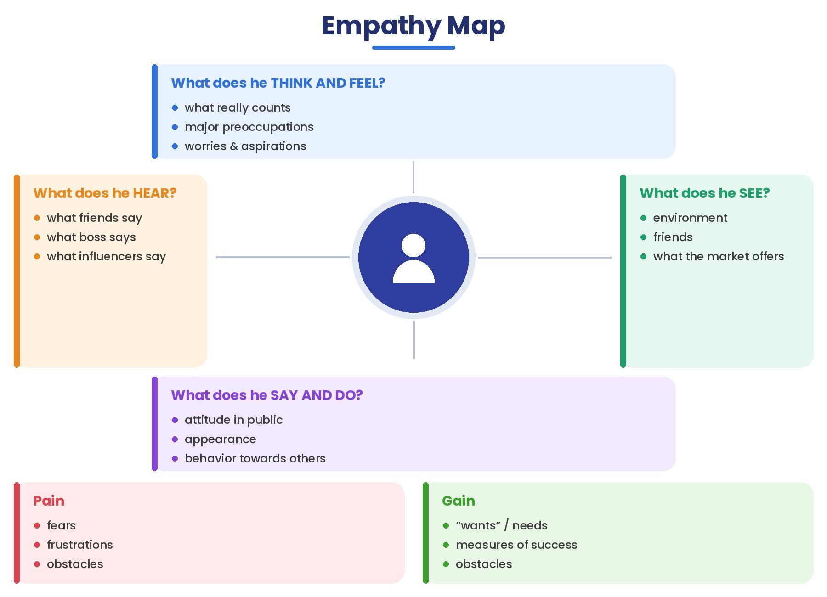

Example: Food Ordering & Delivery Application
